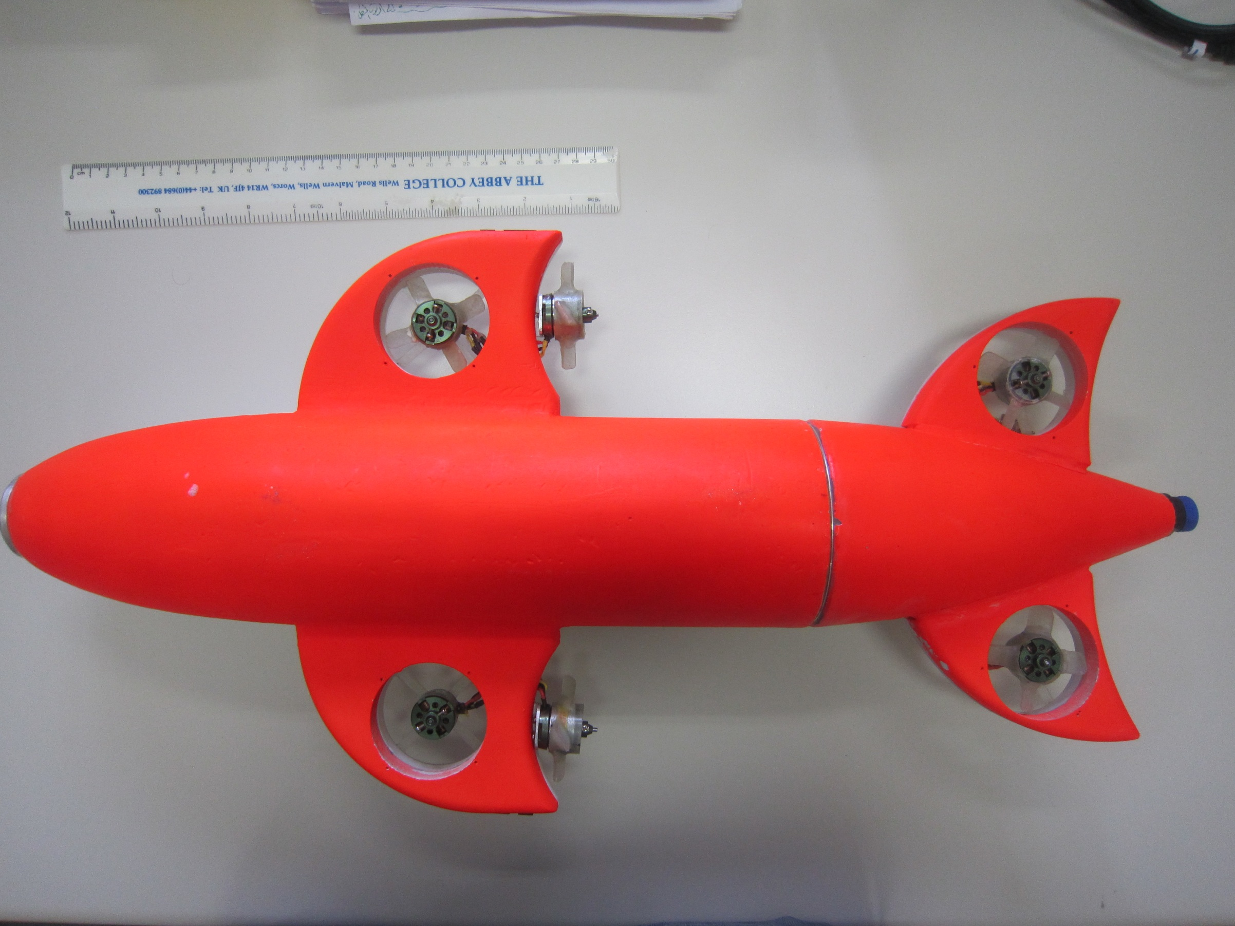

10.5 cm

9.2 cm

8.7 cm

6.3 cm

17.5 cm

5.6 cm

9.2 cm

12.8 cm

2.3 cm

9.5 cm

10.5 cm

4.5 cm

60 cm